Retrieve Invoices

Purpose:
- This Job Aid illustrates how to retrieve invoices.
Steps:
- Enter your credentials, i.e. Email and Password. Then select the SUBMIT button.
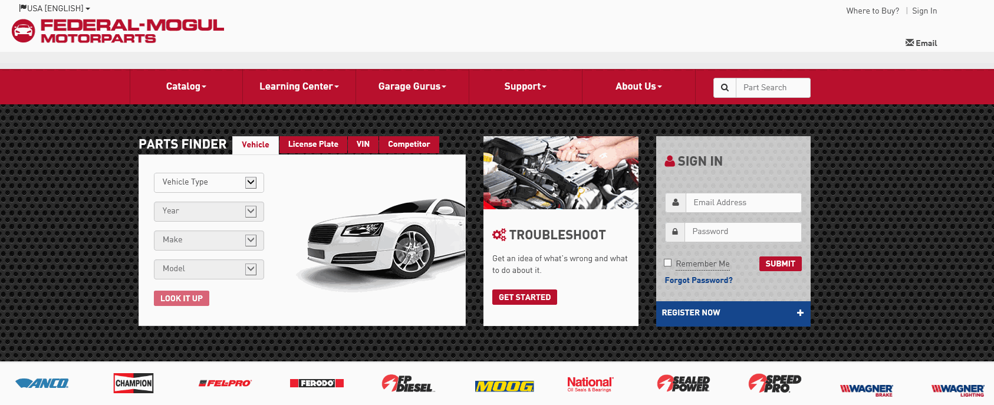

- Select My Account.
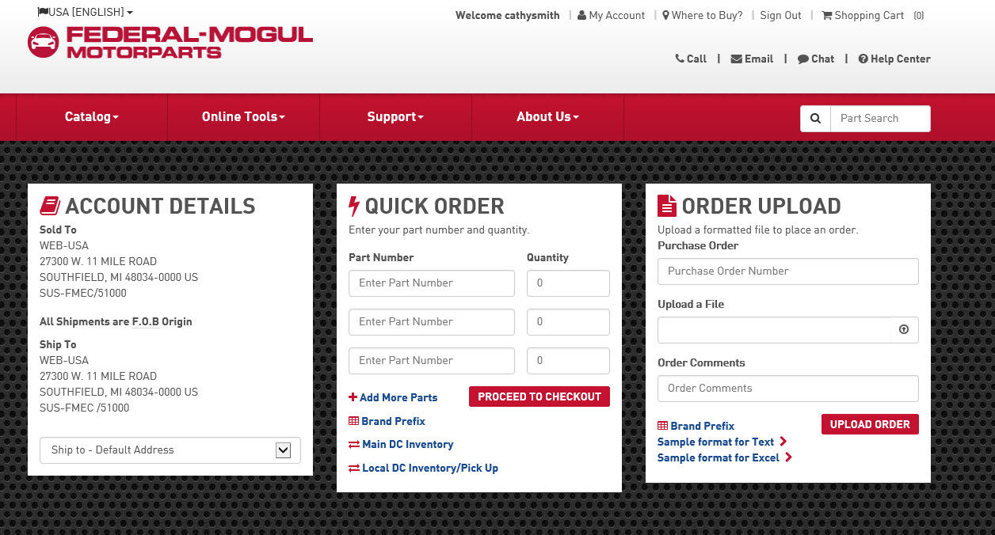
- Select Order history.
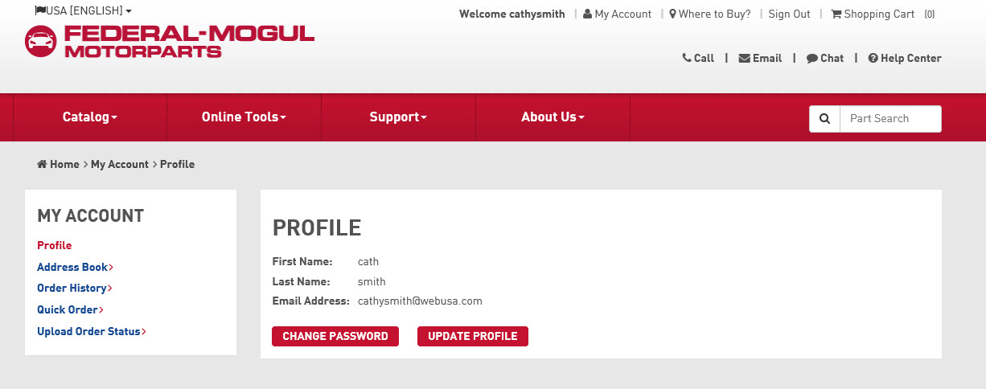
- The Order history screen appears.
- You can search for Invoices using various search criteria such as Purchase Order #, Invoice #, Start Date, End Date, or Order Status (Credit Memo, Invoice, or All).
- Enter the search criteria.
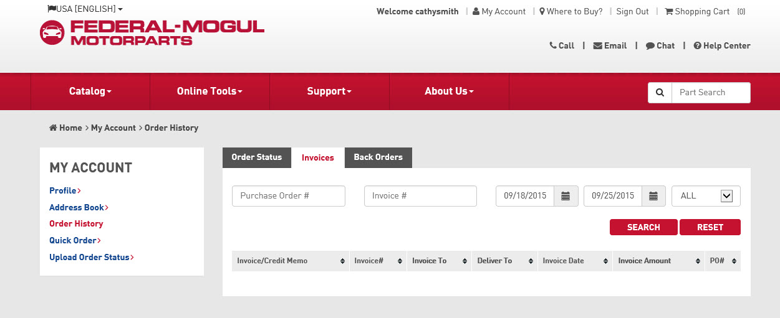
- Select the SEARCH button.
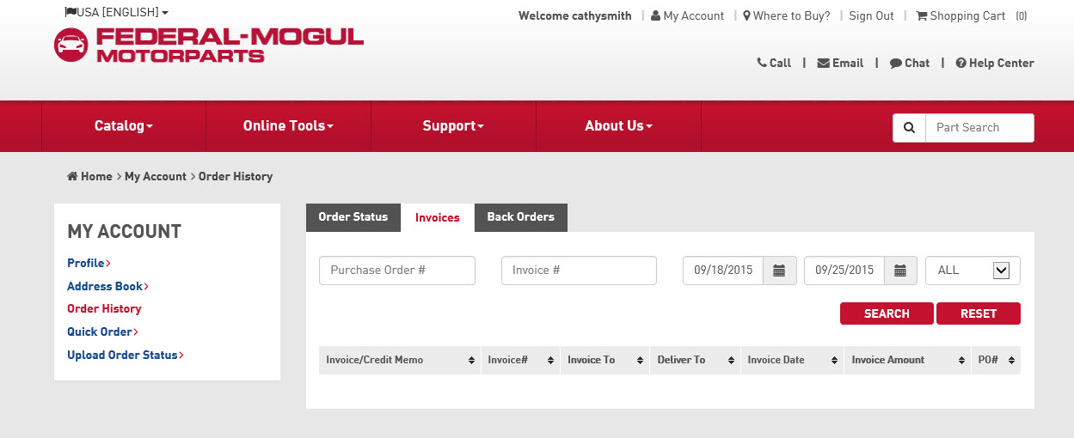

- The search results are displayed.
- Select the Invoice # link to view the invoice.

