Locate Customer Service Resources

Purpose:
- This Job Aid illustrates how to contact Customer Service Representatives (CSRs), Technical Line Support, and locate help documents.
Steps:
- Enter your credentials i.e. Email and Password. Then select the SUBMIT button.
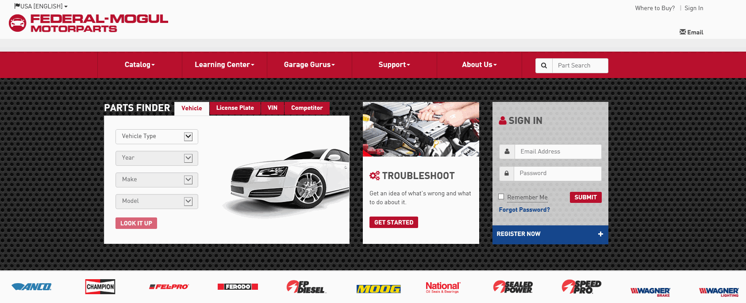
- There are several ways you can contact Customer Service Representatives. At the top of the page you will see links for Call, Email, Chat, and Help Center.
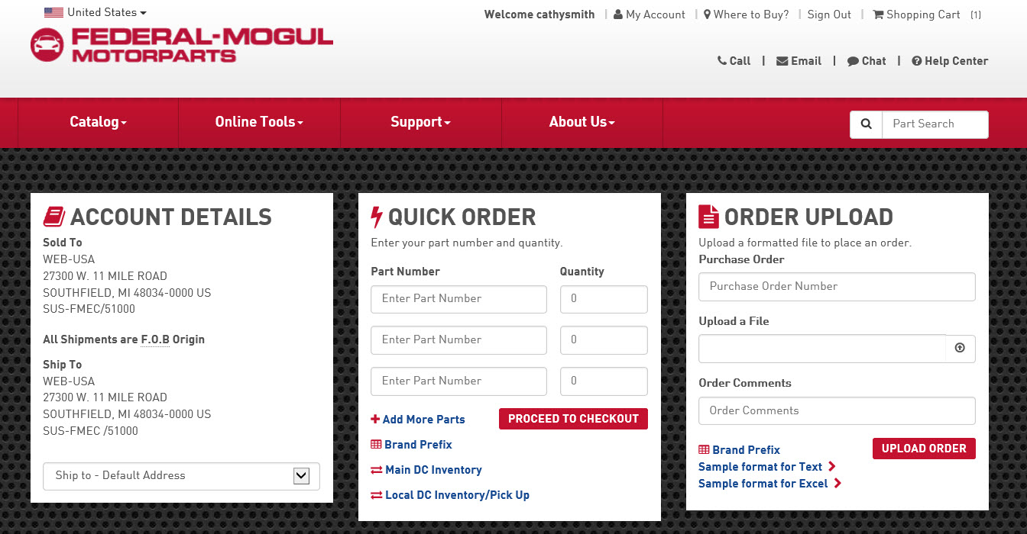
Call Link
- The Call link will bring up the Technical Line and Customer Service menu. Select the Technical Line link to view the phone number and hours.
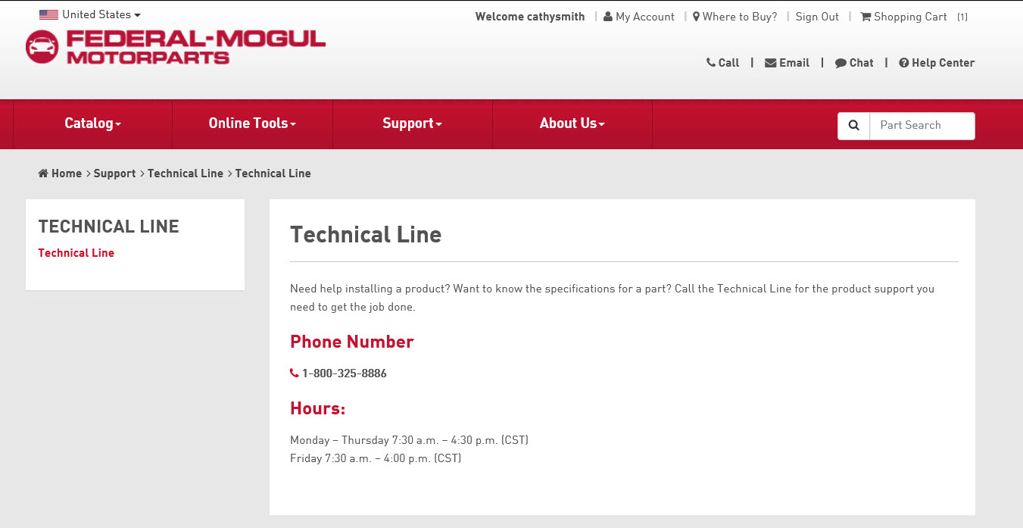

- Select the Customer Service link to see the phone number and hours.
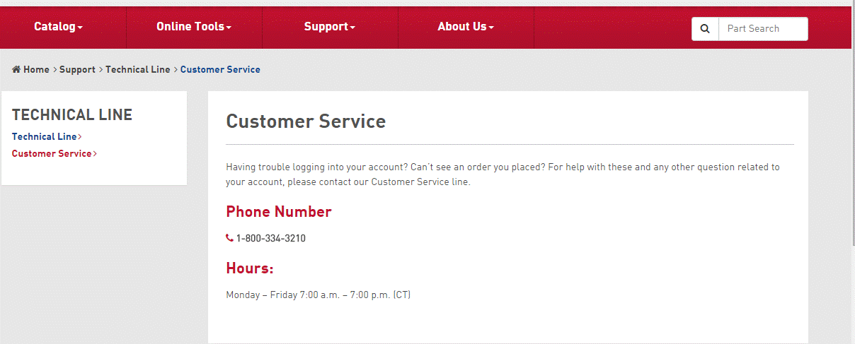
Email Link
- When you select the Email link, you will be given a contact form to complete.

Email Link Continued
- The CONTACT FORM will open. Complete the required information. When complete, select the SUBMIT button at the bottom of the page.
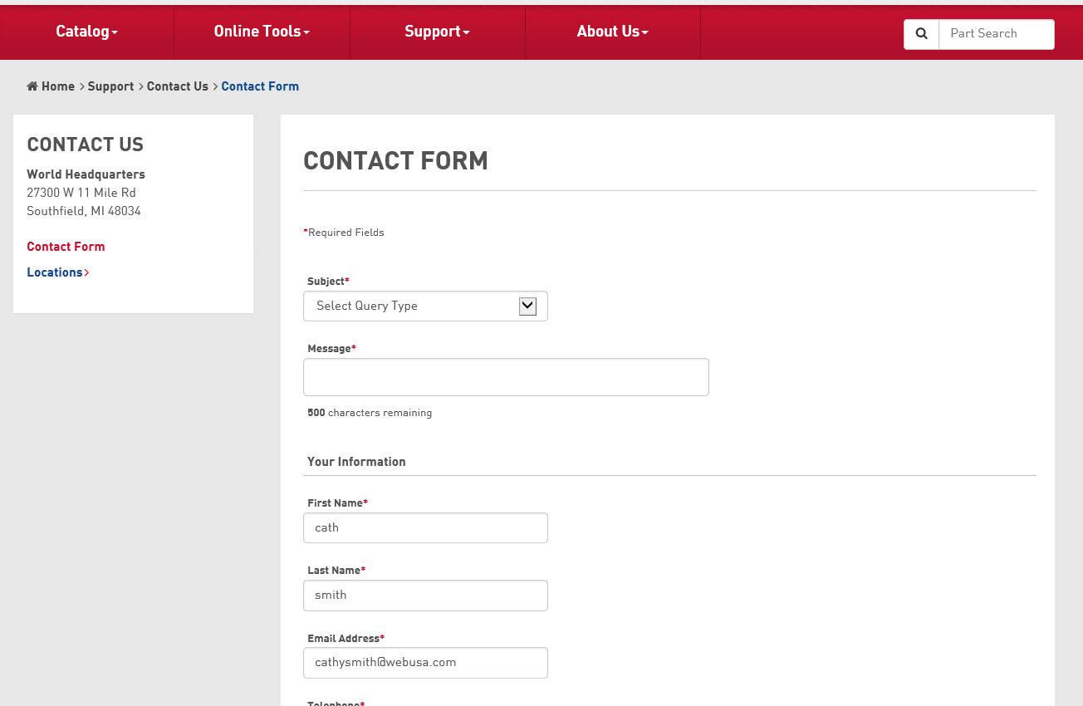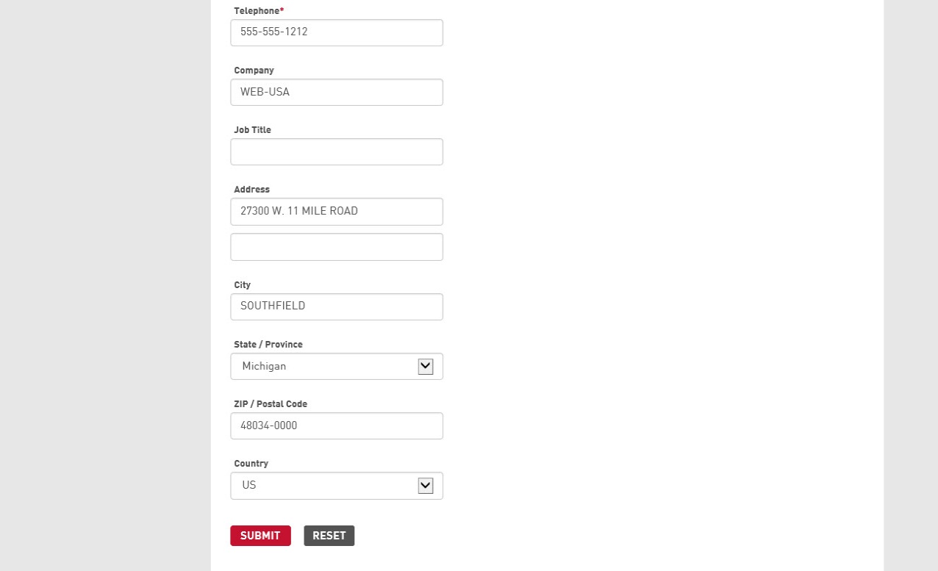

Chat Link
- Select the Chat link to speak directly with a CSR. The Chat dialog box will open automatically.
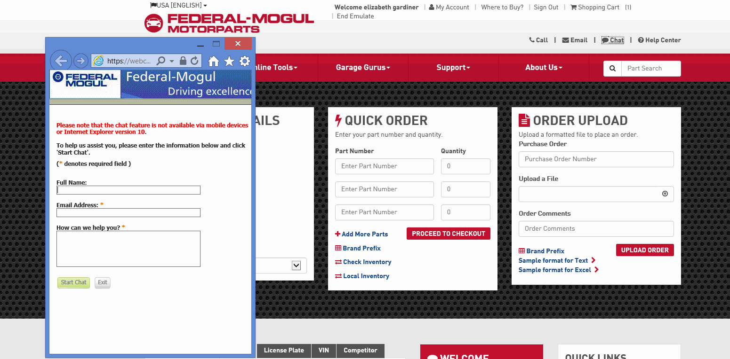
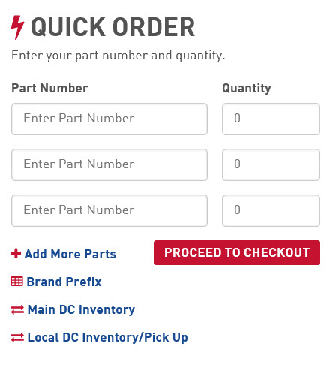

Help Center Link
- Select the Help Center link.

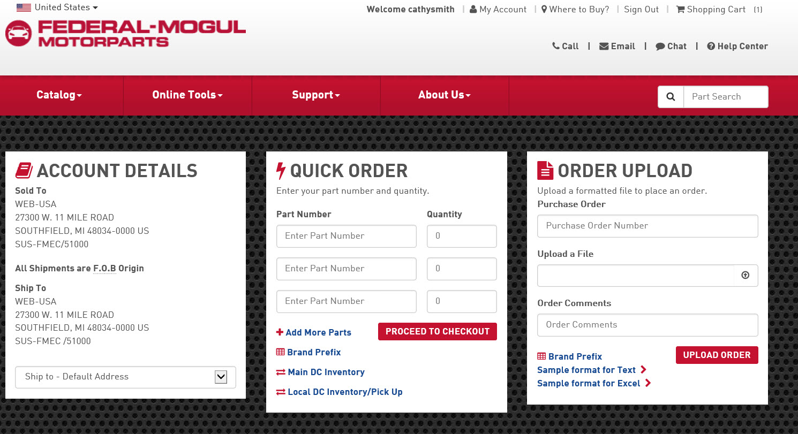

- Additional resources will be listed to answer any questions you may have.

