Check Inventory
Purpose:
- This Job Aid illustrates how to check inventory for a part.
Steps:
- Enter your credentials, i.e. Email Address and Password. Then select the SUBMIT button.
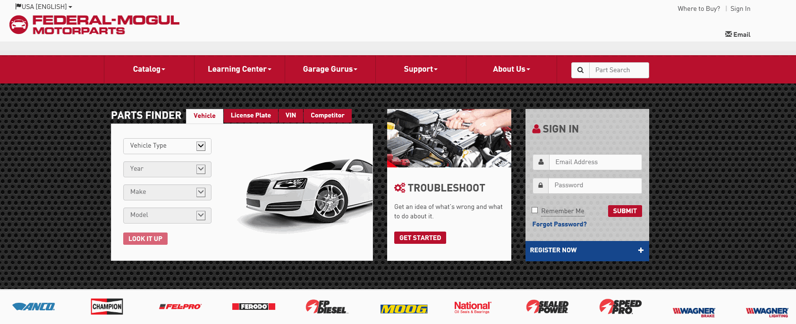
- If needed, select Brand Prefix to identify the prefix to be added to the part number. Do not include any spaces when entering the prefix and part number. For example, the Wagner Lighting part H6054 should be entered as LWLH6054. The Brand Prefix has to be used on all product lines excluding Felpro, Sealed Power, SpeedPro, and FP Diesel. Select the x in the upper right of the pop-up to close the Brand Prefix List window.
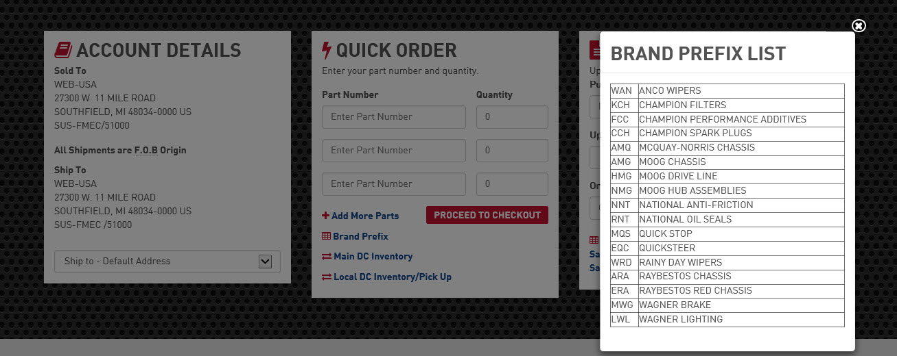

- Enter the Part Number and Quantity.
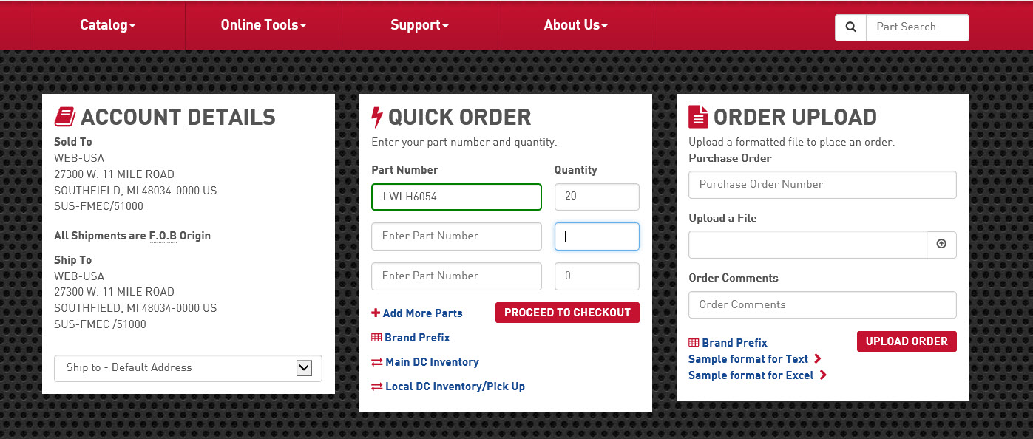

- After entering the part number and quantity, select Main DC Inventory to obtain the current inventory of the part.

- The INVENTORY CHECK dialog box will display the Part Number, Location, and Available quantity if the part requested is in stock. If the entire quantity is not in stock, the check will show the quantity that is available.
- Select the x to close the INVENTORY CHECK dialog box.
