Brand Prefix

Purpose:
- This Job Aid illustrates how to use the Brand Prefix list.
Steps:
- Enter your credentials, i.e. Email Address and Password. Then select the SUBMIT button.
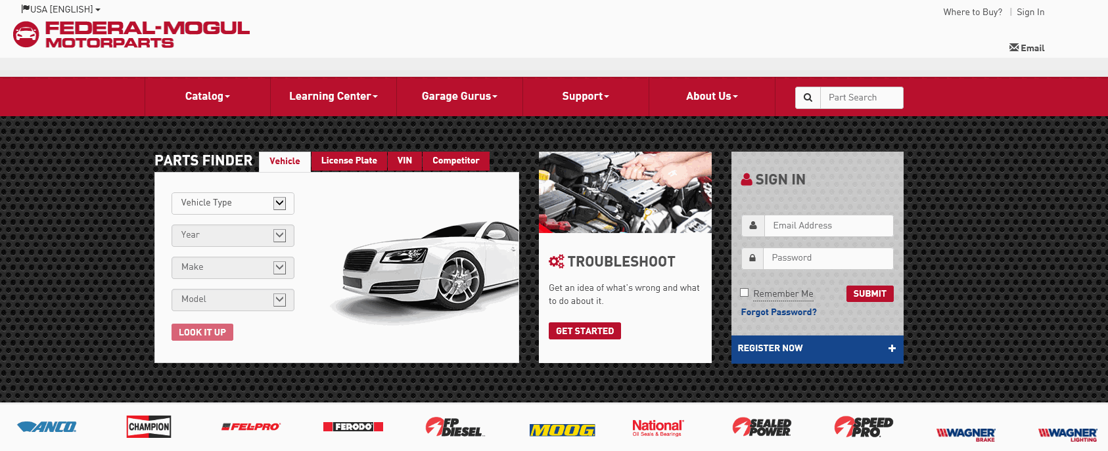
- In the QUICK ORDER menu, you will see the Brand Prefix link.

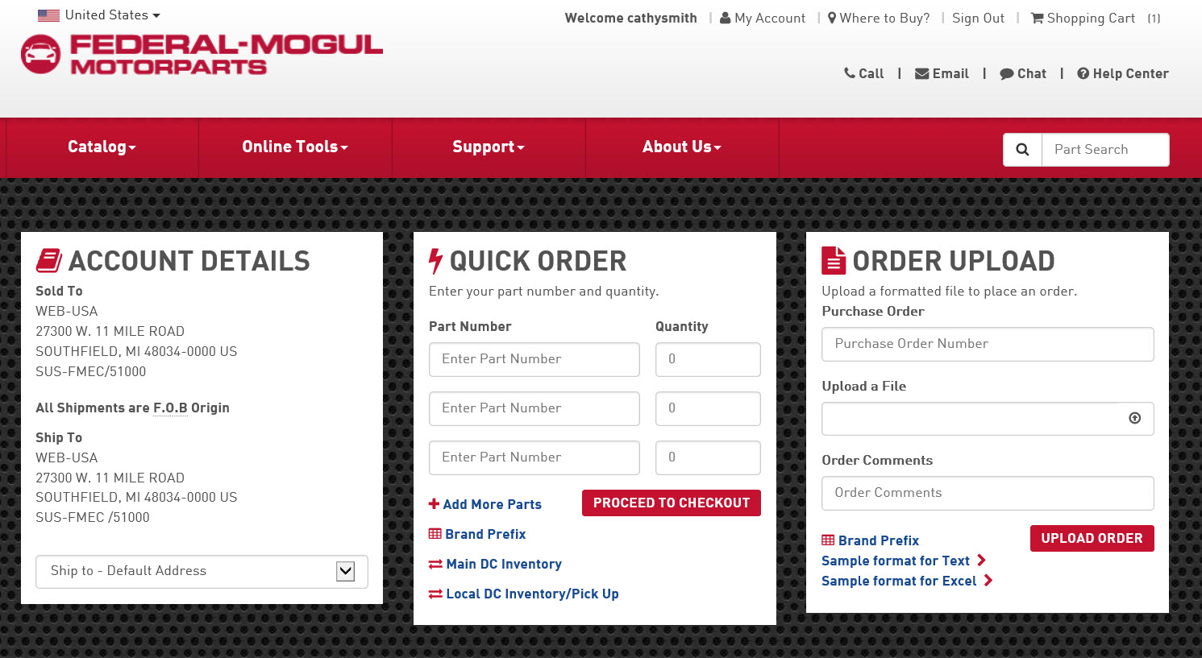

- Select the link to view the list.
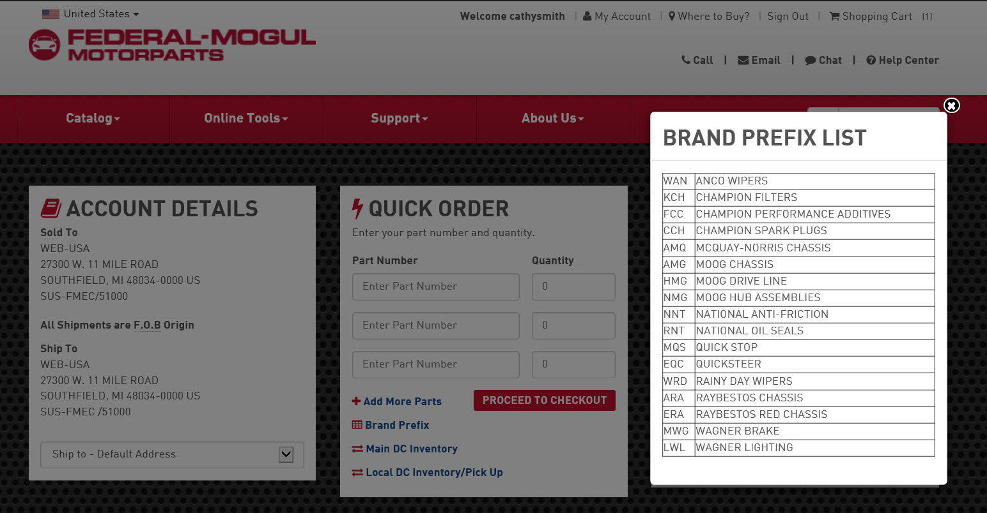

- The need to use the Brand Prefix is driven by part number. The Brand Prefix has to be used on all product lines excluding Felpro, Sealed Power, SpeedPro, and FP Diesel.
NOTE: The most common Brand Prefix information is shown below. If you have questions, or need a Brand Prefix that’s not listed, please contact Customer Service.

